Texts to edit
Below
proof reading and editing practice
extract from charlie and the chocolate factory, by roald dahl

oh what a man he is this mr willy wonka cried grandpa joe
did you know for example that he has himself invented more than two hundred new kinds of chocolate bars each with a different centre each far sweeter and creamier and more delicious than anything the other chocolate factories can make
mr willy wonka can make marshmallows that taste of violets and rich caramels that change colour every ten seconds as you suck them and little feathery sweets that melt away the moment you put them between your lips he can make chewing gum that never loses its taste and sugar balloons that you can blow up to enormous sizes before you pop them with a pin and gobble them up

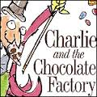

thanks for the knife

an excerpt from the hunger games by suzanne collins.
sixty seconds that s how long we re required to stand on our metal circles before the sound of a gong releases us step off before the minute is up and land mines blow your legs off sixty seconds to take in the ring of tributes all equidistant from the cornucopia a giant golden horn shaped like a cone with a curved tail the mouth of which is at least twenty feet high spilling over with the things that will give us life here in the arena Food containers of water, weapons medicine garments fire starters strewn around the cornucopia are other supplies their value decreasing the farther they are from the horn for instance only a few steps from my feet lies a three foot square of plastic certainly it could be of some use in a downpour but there in the mouth i can see a tent pack that would protect from almost any sort of weather if i had the guts to go in and fight for it against the other twenty-three tributes which i have been instructed not to do
we re on a flat open stretch of ground a plain of hard packed dirt behind the tributes across from me i can see nothing indicating either a steep downward slope or even a cliff to my right lies a lake to my left and back sparse piney woods this is where haymitch would want me to go immediately
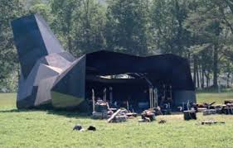
i hear his instructions in my head just clear out put as much distance as you can between yourselves and the others and find a source of water

harry potter and the goblet of fire
by j k rowling
chapter one
the riddle house

the villagers of little hangleton still called it the riddle house even though it had been many years since the riddle family had lived there it stood on a hill overlooking the village some of its windows boarded tiles missing from its roof and ivy spreading unchecked over its face once a fine looking manor and easily the largest and grandest building for miles around the riddle house was now damp derelict, and unoccupied
the little hangletons all agreed that the old house was creepy half a century ago something strange and horrible had happened there something that the older inhabitants of the village still liked to discuss when topics for gossip were scarce the story had been picked over so many times and had been embroidered in so many places that nobody was quite sure what the truth was anymore every version of the tale however started in the same place fifty years before at daybreak on a fine summers morning when the riddle house had still been well kept and impressive a maid had entered the drawing room to find all three riddles dead.
the maid had run screaming down the hill into the village and roused as many people as she could
lying there with their eyes wide open cold as ice still in their dinner things
the police were summoned and the whole of little hangleton had seethed with shocked curiosity and ill disguised excitement nobody wasted their breath pretending to feel very sad about the riddles for they had been most unpopular elderly mr and mrs riddle had been rich snobbish and rude and their grown up son tom had been if anything worse all the villagers cared about was the identity of their murderer for plainly three apparently healthy people did not all drop dead of natural causes on the same night
the hanged man the village pub did a roaring trade that night the whole village seemed to have turned out to discuss the murders they were rewarded for leaving their firesides when the riddles cook arrived dramatically in their midst and announced to the suddenly silent pub that a man called frank bryce had just been arrested
frank cried several people never
frank bryce was the riddles gardener he lived alone in a run down cottage on the grounds of the riddle house frank had come back from the war with a very stiff leg and a great dislike of crowds and loud noises and had been working for the riddles ever since

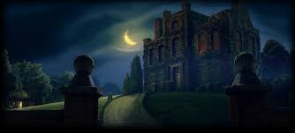

Diary of a wimpy kid hard luck

MARCH
monday
moms always saying that friends will come and go but family is forever well if thats true i could be in for a rough ride i mean i love my family and all but im just not sure we were meant to LIVE together maybe
itll be better later on when were all in different houses and only see each other on holidays but right now things are just a little dicey

im surprised moms always pushing the family message since she and her sisters dont really get along maybe she thinks if she keeps
repeating it to me and my brothers then well come out different but if i was her i wouldnt hold my breath i think mom is just trying to make me feel better about my situation with rowley anyway rowleys been my best friend ever since he moved into my neighbourhood but things have really changed between us recently and its all because of a GIRL
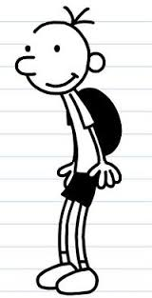
believe me the last person in the world i ever thought would get a girlfriend was ROWLEY

i always thought ID be the one in a relationship and rowley would be the guy everyone kind of felt sorry for i guess ive got to give rowley some credit for actually finding a girl who likes him but i dont
have to be HAPPY about it back in the good old days it was just me and rowley and we hung out and did whatever we wanted if we felt like blowing bubbles in our chocolate milk at lunch then thats exactly what
we did

Supplied by Penguin Books Ltd Copyright (c) Wimpy Kid, Inc.

