Book Review:
Grandpa’s Great Escape

Grandpa’s great escape is about a boy called Jack and a World War 2 Soldier (aka, his grandpa). The grandpa starts to forget lots of things and soon after goes to Twilight Towers (partly a prison for people). Now it’s up to Jack to save his grandpa from this place.
I would rate this 4.6 out of 5 as it has lots of funny comedy in it. It is certainly one of my favourite books. I would recommend it to 5+ as there aren’t any bad words.
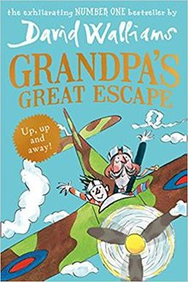
I hope you all will enjoy it as much as I do.

