English
Wednesday 6th January 2021
LO - to use speech punctuation accurately

Look at these sentences. Discuss whether they are correct or not, why and how they can be improved.

Look at the state of your room said Mum as she walked into Tom’s bedroom
Slowly, the girl looked up, “I’m not afraid of you she said.
“Go away!”, she replied. “Im not interested in the game anymore”.
“Good morning, “ Mrs Smith said, “what a beautiful day it is!”

The rules of speech punctuation

A new line is required each time a character begins a new speech.
Speech marks open the quote.
Every line of speech begins with a capital letter.
The speech ends with either a comma, stop, question or exclamation mark.
Reporting clauses are used at the end and finish with a full stop.

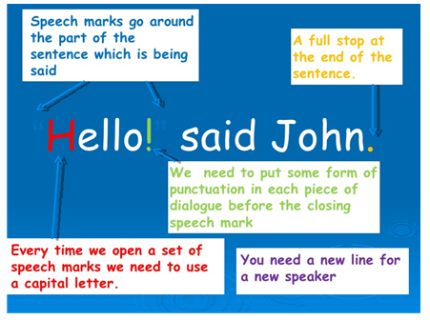
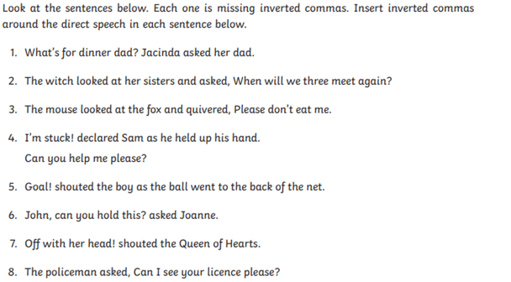
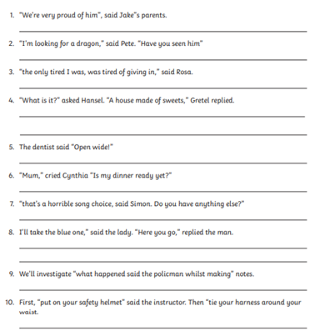
Spot the mistake

