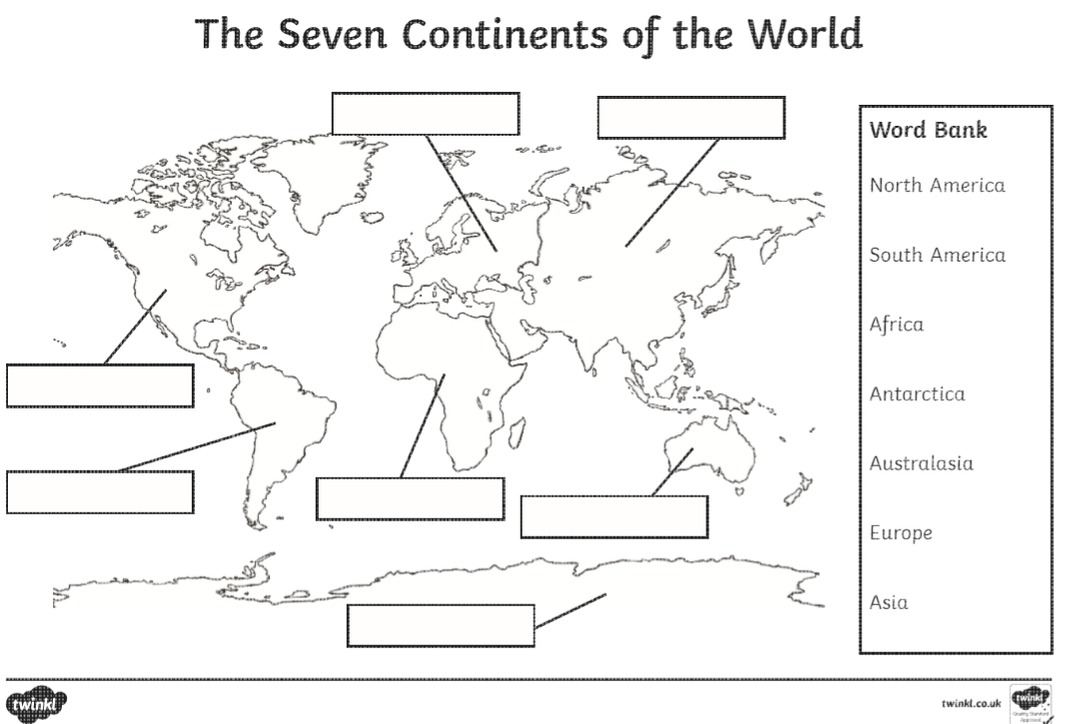

Thursday 23rd April 2020

L.O: To know the 7 continents of the world

Challenge: Can you draw a famous landmark/animal or plant for each continent?