Tuesday 5th May Geography Task To use geographical vocabulary
Use the space at the side to label the things that you can see in these pictures of two very different landscapes in the USA. Try to use geography words like lakes, mountains, valleys, dunes, sea, as well as labelling the living things you can see
Which one do you think is Florida and which one Alaska?
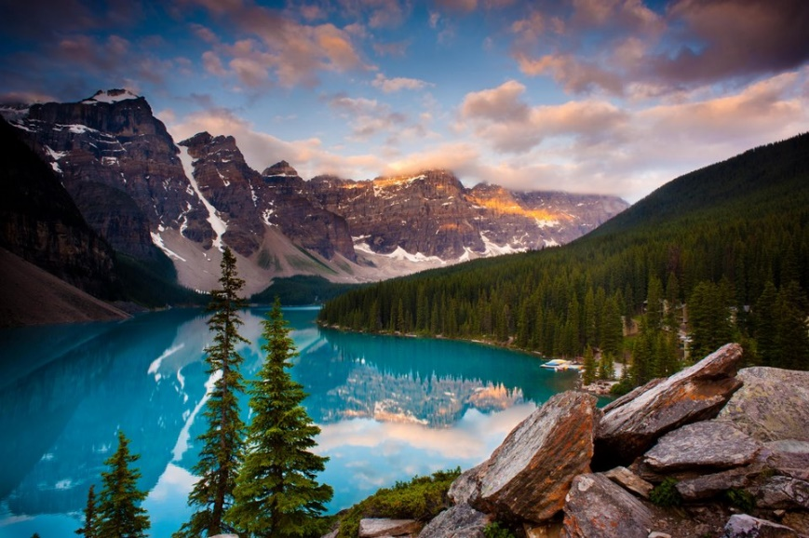

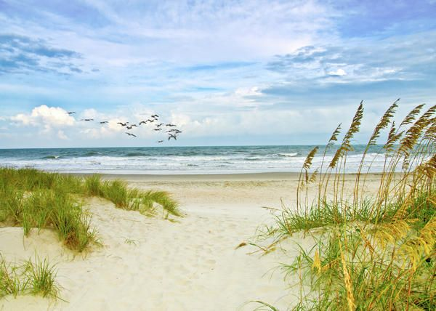

Write 2 or 3 sentences that describe and explain the landscape that you like best or would most like to visit.
____________________________________________________________________________________________________________________________________________________________________________________________________________________________________________________________________

