May 2020
L.O: To know some facts about the continent of Africa
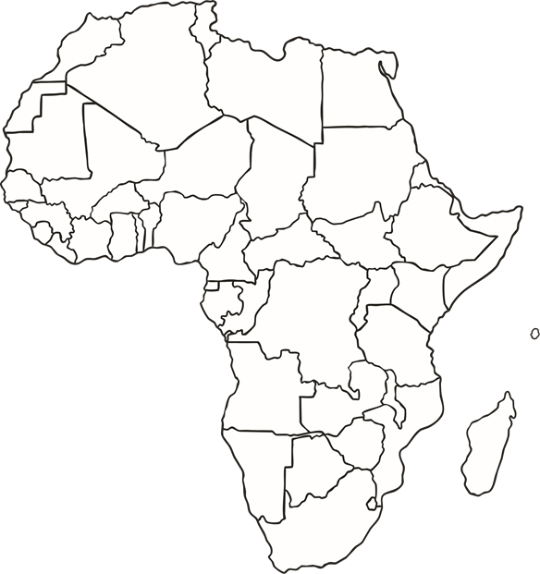
Can you label the ocean that is on the West coast of Africa and the one that is one the East coast?
Can you find and label the country of Ghana?
What other African countries can you label?
1* challenge – Label two countries
2** challenge – Label 5 countries
3*** challenge – Label more than 5 countries
Final challenge: Draw a famous landmark from Egypt and South Africa.

