Animals of the Rainforest – reading comprehension for Monday 1st June 2**
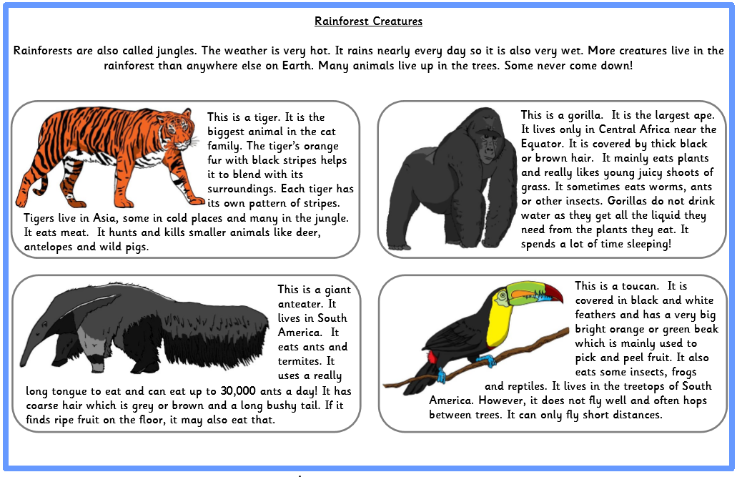
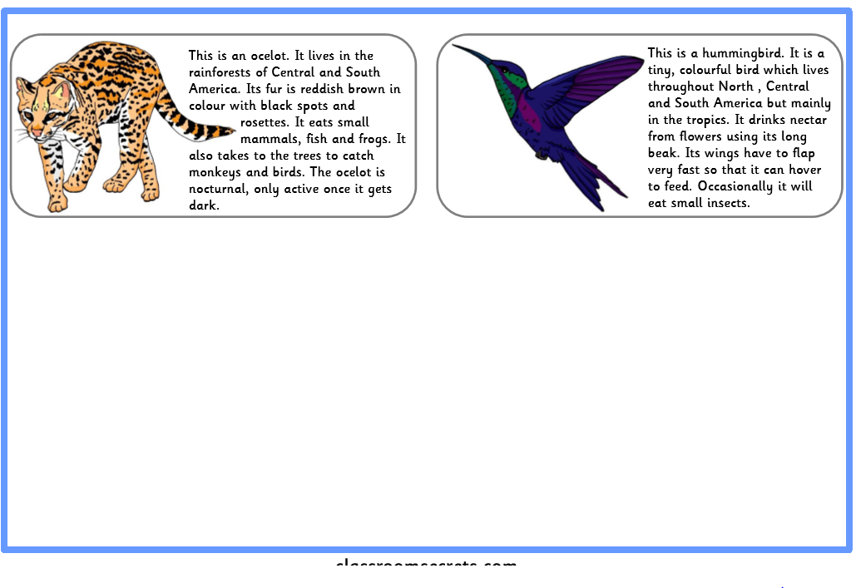
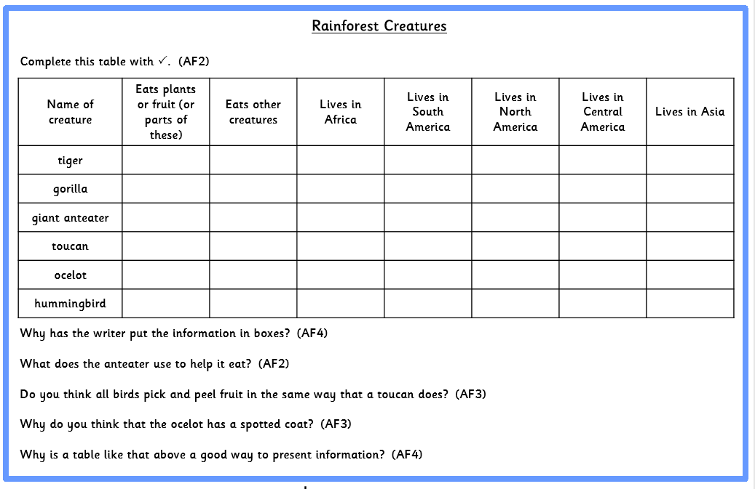
Ignore the codes that say AF and then a number. That is just telling teachers what the assessment focus is. It doesn’t show where to look for the answer.

Answers
