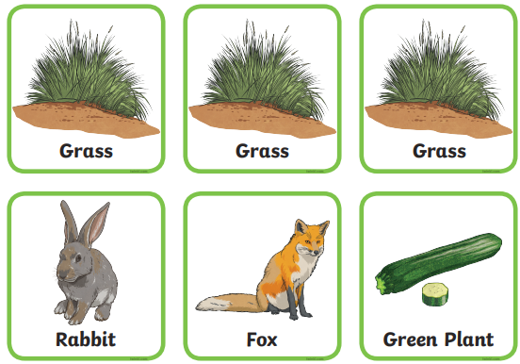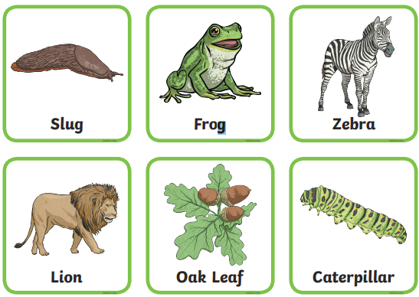
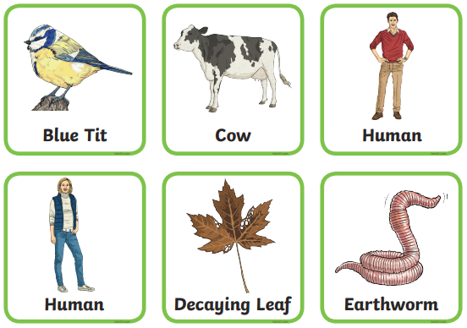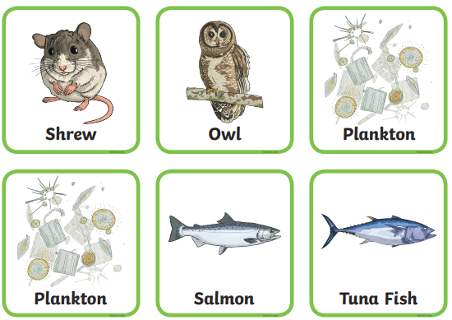
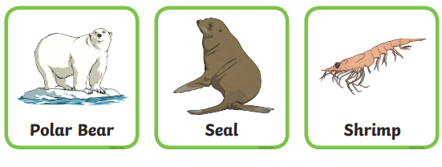
Use these cards to make as many food chains as you can. Remember that a food chain always begins with a producer usually a green plant that has produced its own food using energy from the sun.
Remember that different animals live in different habitats so they will only be able to eat other animals or plants that are in the same type of habitat.
Finally, please use the plankton card for ocean food chains, but ignore the picture on the cards. I’ve no idea what plankton look like but I’m pretty sure it isn’t like this!

