Tuesday 23rd June
L.O: To create a Robert Falcon Scott Fact File
S.C: I know that Scott was an explorer
I know the country he was born in and the continent he explored
I know the year he was born and the year he died

Robert Falcon Scott
Date and Place of Birth
Date of death
Captain Scott is significant because ________________________________________________________________________________________________________________________________________________________________________________________________________________________________________________________________________________________________________________________________
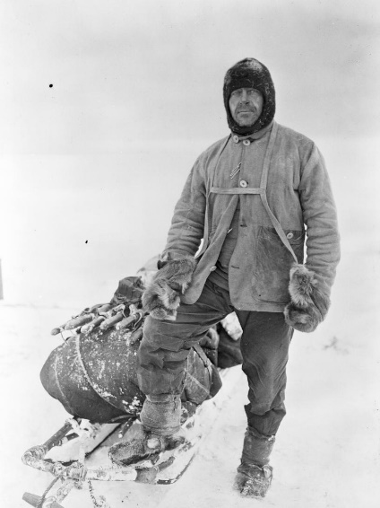 | An interesting fact about Scott  ______________________________________________________________________________________________________________

