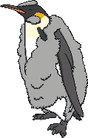
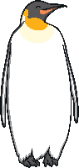
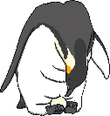
L.O: To explain the lifecycle of an Emperor Penguin
The lifecycle of an Emperor Penguin
1. Laying an egg
5. Fledging
1._______________________________________________________________________________________________________________________________________________________________________________________________________________________________
5.________________________________________________________________________________________________________________________________________________________________________________________________
4._________________________________________________________________________________________________________________________________________________________________________
3.___________________________________________________________________________________________________________________________________________________________________________________
2._________________________________________________________________________________________________________________________________________________________________________
2, Incubation and hatching
4. Moulting
3. Penguin chicks

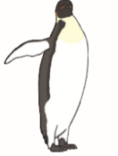

Emperor Penguin Word Bank
Nouns | verbs | adjectives | other
beak (bill) | lay | black | carefully
feathers down | pass | grey | gently
Flippers feet | huddle | white | because
egg | waddle walk | fluffy | when
ocean | moult | downy | that
ice | fledge | waterproof
male female | slide | sleek
brood pouch | eat feed | webbed

June 2020
L.O: To write an explanation of the lifecycle (of an Emperor Penguin)
S.C:
Must:  - Write in complete sentences with full stops and capital letters  - Use the present tense (it lays and egg, not it laid an egg)  - Form your letters carefully and leave clear spaces | Should:  - Join short sentences or phrases using conjunctions  - Include a question  - Check your spellings | Could:  - Use joined handwriting  - Add as many details as you can to make your writing as interesting as possible  - Choose some interesting words including some that end with -ful, -less, or -ly
Have you ever watched wildlife programmes about the amazing life of Emperor penguins?
Read all about their lifecycle here.
1. In May, the female penguin lays an egg but she doesn’t look after it herself. Instead she carefully passes the egg to the male penguin and she returns to the ocean so that she can eat.
2. The male penguin gently tucks the egg into his brood pouch which is a flap of skin just above his feet. He incubates it here for most of the cold Antarctic winter until it hatches in July or August.
Did you know that a male penguin can produce a liquid which is like milk to feed his chick while he waits for the female to return?
3. The fluffy chick is covered in grey downy feathers. At first its mother feeds it when she returns to the colony full of fish from the ocean. Then the mother and father take turns caring for the chick and going back to the ocean for food.
4. When the chicks are a bit older, they begin to lose their fluffy feathers and they grow sleek, waterproof feathers instead. This is called moulting. They do this because soon they will go to the ocean themselves and they will learn to swim and find their own food.
5. Eventually the chicks will be old enough to go to the ocean. They will stay there for about 5 years flying through the sea and catching plenty of fish. When they are about 5 years old they will return to the colony on the ice so that they can breed and begin a new lifecycle.

