Alien Pictures by Lance Cardinal
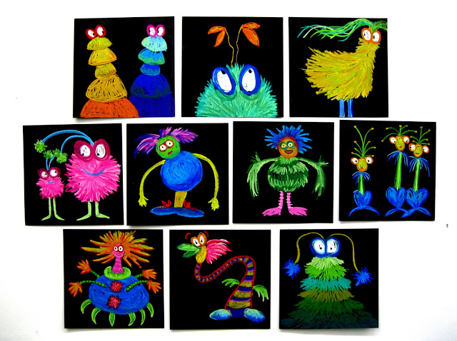
The artist Lance Cardinal created these lovely alien pictures using pastels on black paper.
Choose whatever art equipment you have available to draw some pictures like these. Felt tip pens, colouring pencils or even paint.
You can copy them exactly or you can use them as inspiration for your own pictures.
Have fun!

