Long ago and Far Away- Start of Topic Quiz
L.O: To show what I already know?
Answer these questions as well as you can. If you don’t know the answer, just write: Don’t Know
Sort the colours into primary and secondary
Red orange yellow
Green blue purple
Primary Secondary
Put these space travellers in the order that they first went into space
- Buzz Aldrin
- Yuri Gagarin
- Tim Peake
- Helen Sharman
Who is this and why is he famous?
______________________________
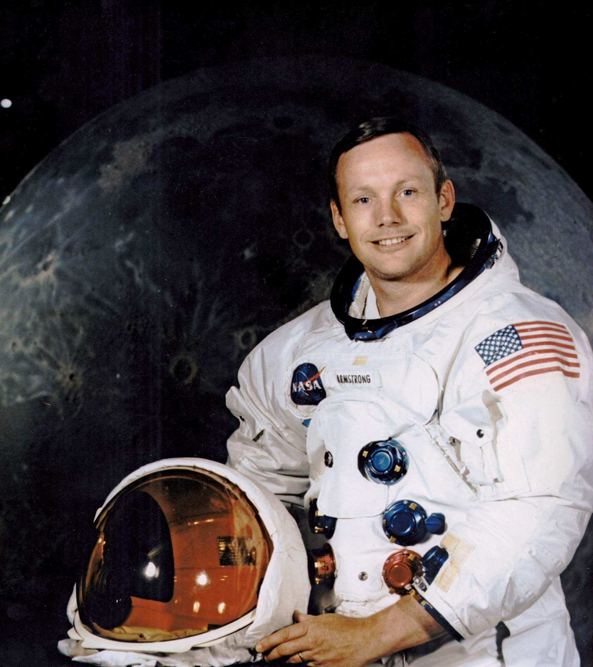

Circle the things that do not produce light.
Sun
Candle
Lightning
Moon
Stars
Mirror
Water
Fire

Name the planets in our Solar System

Name some natural materials
_____________________________________________________________________________________

Name the continents of the world
____________ _____________
____________ _____________
___________ _____________
Name the oceans of the world.
________________________________________________________________________________

