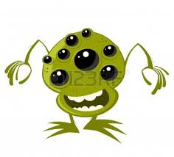
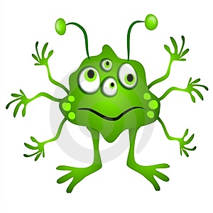
Tuesday 5th January 2021
L.O: To create an imaginary fact file
S.C: I can use my imagination to invent facts
I understand the terms:
Gender (usually male or female),
Diet, (what you eat),
Features (key things in your appearance)
Abilities (things that you can do…may be impossible for a human)

Name |  | Picture
Gender
Planet
Age
Diet
Special Features
Special Abilities
Likes and interests

