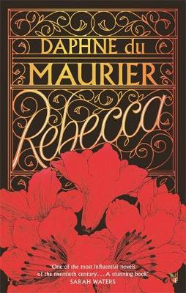

Rebecca By Daphne du Maurier

Rebecca is written in the first person. The book is all about Caroline. Her husband, Maxim de Winter whose first, and now dead wife Rebecca, haunts Manderley the big estate, owned by Maxim. Caroline is from France, Monte Carlo. This is a completely new environment than she is used to and as well as her insecurity, she is on the verge of craziness.

This gothic story is full of crime, mystery and romance. Throughout the time reading this book, I was hooked. It was like being on an emotional rollercoaster, full of delight and despair. I would say my favourite character is Caroline. Her thoughts are really interesting because of the depth of detail she goes into. I would recommend this book from the age of 10 as it covers some aspects that could be more adult. My rating for this book would be 10 out of 10. After reading Rebecca I‘m inclined to read more of Daphne du Maurier’s work.

By Ella

