My book is: The Chronicles of Narnia The Magician’s nephew.
The author is: C.S.Lewis.

I will rate this book:
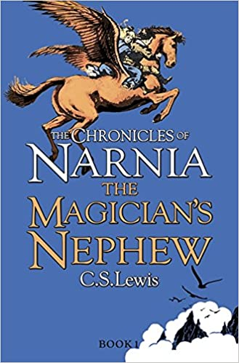
Because I’m always hooked to the book and want to read on.
My favourite part was where Aslan made Fledge (the horse) grow wings.
My favourite scene was where Polly and Digory just appeared in Charn, all alone.

