caring rude happy

beautiful friendly rude angry ugly sly evil clever handsome kind honest nasty gentle pretty wicked cross grumpy horrible brave helpful shy mean noble polite wise calm bold scary smart cruel unkind

furious cunning unkind

unkind cruel charming

26.11.20

\*\*\*L.O: To write sentences describing

a character.

Choose one of the characters and write some sentences using capital letters, full stops and finger spaces.

Jack

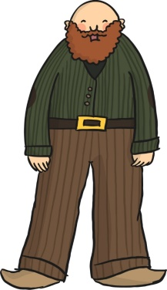

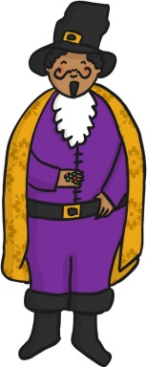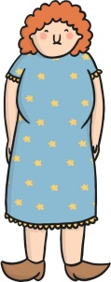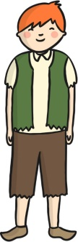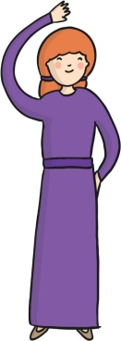

Giant’s wife

Jack

Jack’s mother

Bean seller

Can you write some sentences about the character?

Giant

26.11.20

\*\*L.O: To write sentences describing

caring rude happy beautiful friendly rude angry ugly sly evil clever handsome kind honest nasty gentle pretty wicked cross grumpy smart cruel unkind

a character.

Choose one of the characters and write

some sentences using capital letters,

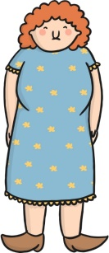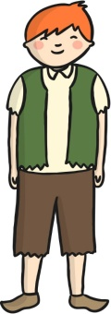 full stops and finger spaces.

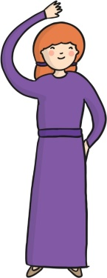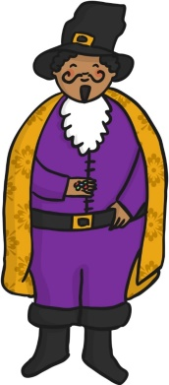

Giant’s wife

Jack

Jack’s mother

Bean seller

Giant

Can you write some sentences about the character?

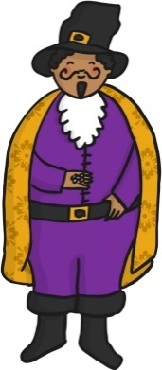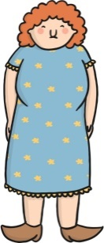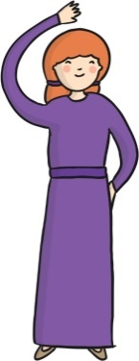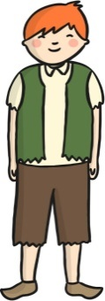

Jack’s mother is kind.

Can you write a sentence about this character?

Giant

26.11.20

\*L.O: To write sentences describing

a character.

Choose one of the characters and write some sentences using capital letters, full stops and finger spaces.

Jack

Giant’s wife

Jack

Jack’s mother

Bean seller

caring rude happy friendly

beautiful kind rude angry ugly sly evil clever handsome

Name

Name

Can you write a paragraph about this character?

Caring rude happy

beautiful friendly rude

angry ugly sly evil

clever handsome kind

honest nasty gentle

pretty wicked cross

grumpy horrible brave

shy mean noble

polite wise calm bold

helpful scary smart

furious cunning unkind

unkind cruel charming

Can you write a paragraph about this character?

Name

Caring rude happy

beautiful friendly rude

angry ugly sly evil

clever handsome kind

honest nasty gentle

pretty wicked cross

grumpy horrible brave

shy mean noble

polite wise calm bold

helpful scary smart

furious cunning unkind

unkind cruel charming