English activities for Thursday 2nd and Friday 3rd April

Thursday 2nd April & Friday 3rd April
L.O: To write a scene from a story
S.C:
Must:  I write in complete sentences with full stops and capital letters.  I check my writing makes sense.  I form letters carefully | Should  I use lots of expanded noun phrases to describe the characters.  I use conjunctions like and, but, or, that, when, because, if to add detail to sentences. | Could:  I use joined handwriting.  I use words ending with suffixes like -ment, -ness, -ly, -ful.  I use apostophes correctly.  I use commas in lists

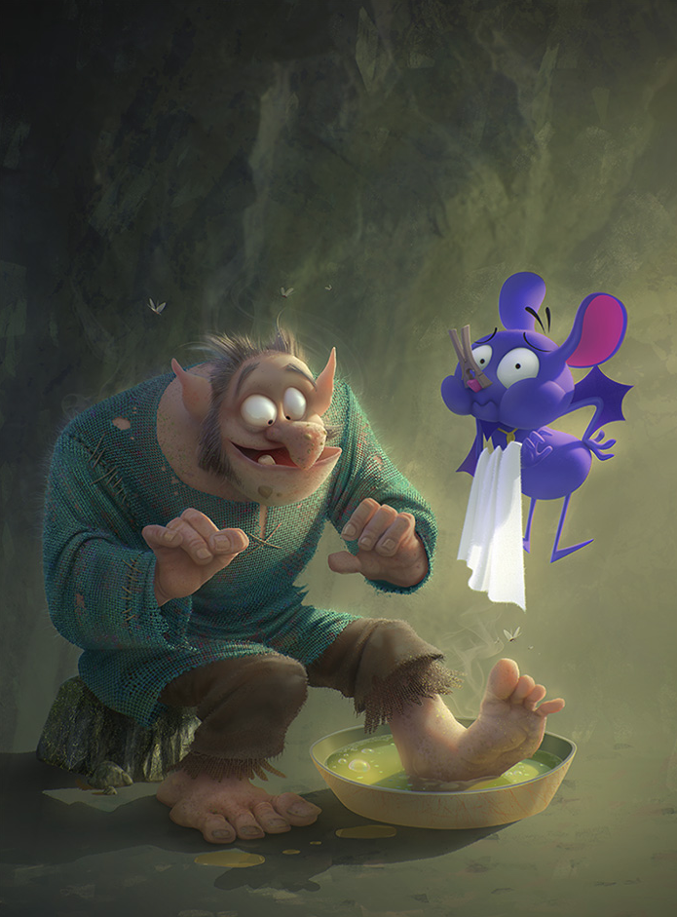
Begin the writing task on Thursday and continue it on Friday.
If you finish the task on Thursday do the following slow write to describe the picture on Friday
Sentence 1 – Begin with a verb ending -ing (For example, Sitting or perching on a rough, flat stone there was a….)
Sentence 2 – Use an expanded noun phrase to describe his foot (For example – His large hairy foot splashed in a bowl of vibrant green liquid)
Sentence 3 – Use a conjunction such as because….(For example – a flying purple mouse put a peg on his nose because the foot was so smelly.)
Sentence 4 – Should be a question – (For example – When did he last wash those filthy toes?)
Questions to think about
What do you think the characters should be called?
Why has the purple creature got a peg on his nose?
Why has the ogre/troll/giant got his foot in the bowl?
What are the characters thinking?
What might they be saying to each other?

Remember write this as a part of a story…don’t just write the answers to the questions.

