Friday 19th June
L.O: To compare 2 story characters (from the story Why does the koala have a stumpy tail?)
Think about the koala and the kangaroo in the story. In what ways are they similar. Write down some similarities between the two pictures.
In what ways are they different. Write things about the kangaroo on the side of the kangaroo and things about the koala near the koala. Include things you know about their appearance and things you know about their personality. When you have done this take one of the animals and write a description of that animal in your writing book.
Different things about the kangaroo
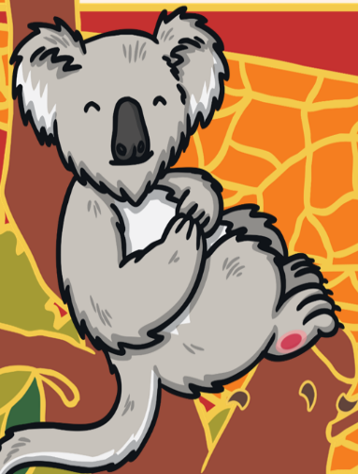
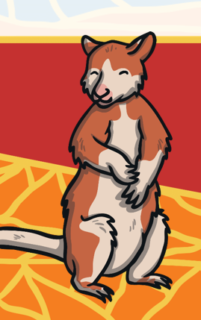
Things that are similar between them Different things about the koala
Useful words: ears eyes nose limbs tail claws fur friendly cheerful hard-working lazy sleepy greedy selfish generous

_______________________________________________________________________________________________________________________________________________________________________________________________________________________________________________________
_______________________________________________________________________________________________________________________________________________________________________________________________________________________________________________________
________________________________________________________________________________________________________________________________________________________________________________________________________________________________________________________

