Nuts About Brazil – vocabulary and grammar work for Wednesday 3rd June
1. Read the words and the definitions. See how many you can match up on your own. Then use a dictionary/google/Alexa/a grown up to help you match up the rest of the words and definitions.
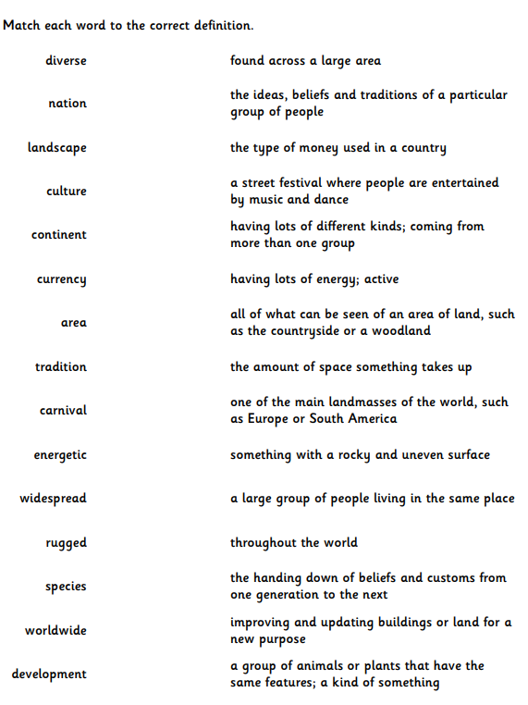

2. Can you find all the words in the wordsearch?
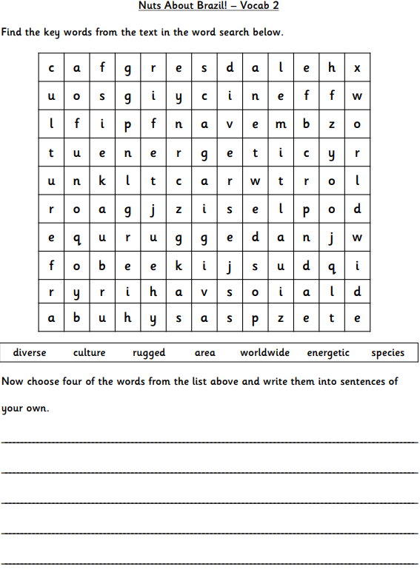

3. Now try some grammar work – using proper nouns
