South American Animal – Fact File

Animal | Appearance | Diet | Habitat | Features | Other
Toucan | 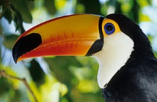 | Mainly fruit  Also insects, frogs and sometimes eggs | Rainforest canopy  Nest in tree hollows | Very large colourful beak  Black body  White throat | Lay 2-4 eggs each year.  Mother and father care for the young  Not good fliers.
3- toed  Sloth | 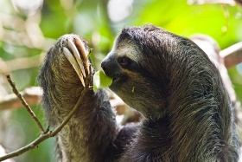 | Mainly leaves that are toxic for other animals | Rainforest canopy | Very sharp claws for climbing | Come down from trees once a week to go to the toilet. One baby born at a time. Hang and climb on mother for 5 months.
Brazilian tapir | 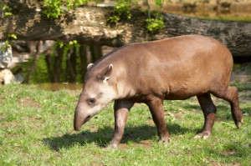 | Leaves, buds, shoots, fruit, small branches | Rainforest, near water- they run to water to escape predators | Flexible snout for eating | About 2m long. Brown fur. Good at swimming and diving.
Green Anaconda | 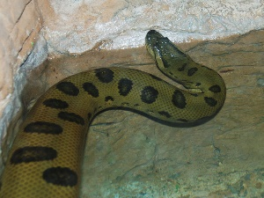
Scarlet Macaw | 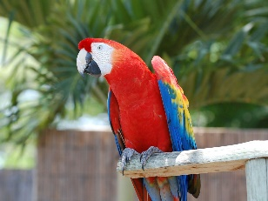
Giant anteater | 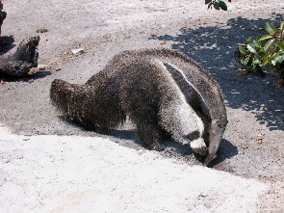
Poison dart Frog | 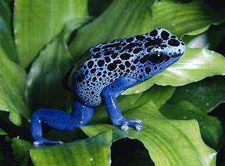 |  |  | Bright colours warn animals they are poisonous | Active during the day
Red-eyed leaf frog

Jaguar | 