This week I would like you to do some research about a country in the continent of Europe.
First you need to choose a country and check with an adult that it is in Europe (It doesn’t have to be in the EU) to count.
Then find out some facts about the country. You can talk to others, use the internet, use books or use any other information that you can find.
Then print out the table below or draw your own table like this(make it bigger though)
Country
Capital City
Flag of the country
What is the main language spoken there
Famous place or landmark
Famous river
Famous food
Famous character from history
Famous person alive today

If I was doing England, I might do this. You can use pictures or words or a mixture of both.
Country | England
Capital City | London
Flag of the country | 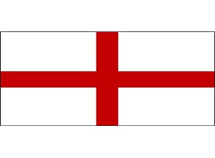
Main language | English
Famous place or landmark | 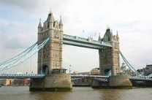  Tower Bridge
Famous River | River Thames
Famous food | Fish and chips
Famous character from history | William Shakespeare
Famous person alive today | 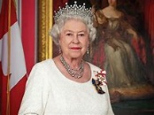  Queen Elizabeth 2nd

Week beginning Monday 27th May
L.O: To know some facts about a country in Europe
First choose your country and make sure that is in Europe
Country
Capital City
Flag of the country
Main language
Famous place or landmark
Famous River
Famous food
Famous character from history
Famous person alive today

Do you know the names of any other European countries?
Write them here

