English for Week Beginning Monday 4th May
This week our English activities will have the theme of North America. We will find out a little bit about the history and geography of this amazing continent as we practise our reading and writing skills.
Monday
Today we will read about the explorer Christopher Columbus who many people say ‘discovered’ America. This is not quite true as you will see when you read the passage that comes from Twinkl.
I will attach the reading sheets in a separate link. There is a shorter passage with some questions and then the answers and a harder passage. If you are a free reader you should be able to do the harder passage. Others should probably try the shorter one.
There are questions to answer after you have done the reading.
Later today you can learn some more about Christopher Columbus using this link. It shows a short cartoon about his life as an explorer.
https://www.bbc.co.uk/bitesize/topics/zhpchbk/articles/znchkmn

Tuesday
Today we will do some reading will which give us some information about the USA which is in the most well known part of the continent of North America. Again the reading comes from Twinkl. It is in the form of a diary of a child who travels from one part of the USA to another. Again I will add this as a separate link. This time there is only one level.
When you have finished the reading, answer the comprehension questions.
Finally (in your writing book) Pretend that you are Tyler and write a diary entry that he might write after he has been to the beach. What would he have done there/eaten/seen/smelt/felt like there?
Try to write 4-6 sentences to describe the day at the beach as if you were Tyler so you can write in the first person I/me/my.

Wednesday
More reading today. This time a Native American fairy tale. It is a bit longer so you may need some help with a few of the words. Again I will attach it as a separate link.
The questions have dogs by them. This is what they mean:
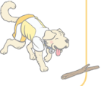
This is a looking question. Look carefully at the text and you will see the answer.

This is a word question. It is asking you to find particular words in the text.

Clues question. The answer is not immediately obvious, but look for clues that help you to work out what the answer must be.
This dog has a crystal ball. You need to predict what might happen next. You know how stories work and what could happen.
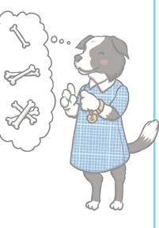Read some events from the story and put them in the order that they happened. When you have numbered the sentences, read through them in that order to make sure that you have got it right.

Thursday and Friday
The USA in North America brings us a lot of our entertainment, including many of the films that we love to watch. Walt Disney and Pixar are famous animated film makers. I’m sure you can think of lots of films by Disney or Pixar
This week we are going to write character descriptions of one or two of the characters from these films.
1. Choose a character that you would like to write about and search for an interesting picture to help you with your description.
Here are two that I have chosen – you can choose your own favourite
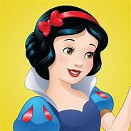
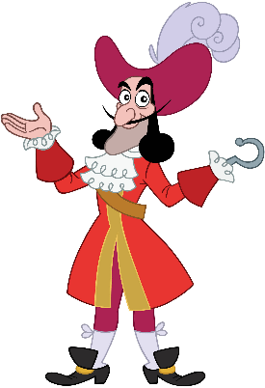

Snow White – a good character Captain Hook – a villain
2. Now begin to think of some features of that character that you want to describe and make some short notes. Don’t forget to use some interesting adjectives ( describing words)
Here is my example for snow white.
Because she is a good character, I have chosen words that show this.
Glossy black hair A deep red hairband Sparkling brown eyes
Soft, flawless skin A sweet friendly smile A flowing yellow dress with a blue top gentle voice helpful and kind caring
3. When you have collected these words, begin to describe the character as if you were writing the start of the story. Don’t actually tell the story. Instead write sentences that tell your reader lots about the character…what they look like….what they sound like….possibly what they smell like….what sort of person they are.
7th May 2020
L.O: To write a description of a story character
S.C:
Must:  Write sentences that make sense and have punctation.  Include some describing words.  Letters that are formed correctly. | Should:  Start sentences in different ways…not always She has…or He has…  Include some good expanded noun phrases.  Use some conjunctions to make your sentences longer. | Could:  Include a simile (compares one thing with something that is similar).  Use a range of punctuation such as !, ?,  Use joined handwriting.

Here is my example – Don’t copy it. Try to use your own words and ideas as much as you can. I have used colours to show you some of the features that I put into the success criteria. You don’t need to use these colours.

Once there was a beautiful, caring girl called Snow White who lived in a magnificent castle. She had glossy hair that was as black as a raven’s wing , cherry red lips and smooth, flawless skin. Her eyes were brown and sparkled like jewels.
On her head she always wore a deep crimson head band and her flowing yellow dress had a blue top. Her smile was sweet and friendly and when she spoke her voice was as gentle as a soft breeze. She was so kind that song birds would come and sit on her hand to eat the food that she offered them and even shy deer would come close as she walked by.

It may take you 2 days to write a really good description of your character. Don’t forget to check it for spelling mistakes, missing words or punctation and places where you can improve it.

If you finish in one day, try a different character on the second day. If you started with a good character, why not try a bad character next time. These are sometimes more fun to write!

Here is my example for Captain Hook…again don’t copy it but you can borrow some of the ideas if they work for the character you chose
Collection of words
Large hat with a flamboyant feather lacy collar fancy red coat vicious looking metal hook piercing eyes sharp pointed moustache thin-lipped smile shiny black shoes with smart gold buckles
My description
Long ago in Neverland there lived a dastardly pirate called Captain Hook. He loved to dress in expensive clothes. His huge hat was trimmed with a flamboyant feather and his shiny black shoes sparkled with gold buckles. His long red coat was trimmed with gold and he felt very proud of himself.
Looking closely at his face, you will see that he has a large jutting chin, a sharp pointed moustache and a thin-lipped evil looking smile. His eyes were as dark as the eyes of shark looking for its prey.
Wherever he went he was tormented by the sound of a ticking clock that reminded him of the crocodile who had bitten off his hand. In its place he had a vicious looking hook.

Who will you describe? – Here are some ideas, but you can choose any character that you like.
A Frozen character, Maleficent, Scar, Ursula, The Little Mermaid One of the 7 dwarves, Alice in Wonderland Woody Buzz Lightyear

If you are not sure how to do this work, you could have a look at some lessons about character descriptions from Oak National academy.

On Wednesday 29th April and Friday 1st May there are two lessons that you can watch that have been taught by a teacher. They are based on a character in a story called something like the firework maker’s daughter but the way they did it can be used for any story. There is also some spelling work which you can skip through at the beginning of the lessons…unless you want to do it…that’s fine, it’s all year 2 words.
https://www.thenational.academy/online-classroom/year-2#schedule

