English for Week beginning Monday 27th April 2020
This week’s English activities will focus around the Twinkl ebook ‘Brenda’s Boring Egg’ and some non-fiction texts about the lifecycle of ducks
These can be found using Twinkl’s home learning hub for Friday 24th April or you can see the book and hear the story being read using the following link
https://www.youtube.com/watch?v=yfcQx81GM30&feature=youtu.be
Can I suggest that the children try to read the words themselves as well as listen to the teacher reading the book.
Monday 27th April
Do the activities on this sheet or straight into your writing book.
Read/listen to the story of Brenda’s Boring Egg
1. Stop after ‘She gazed at her nest with a sorrowful sigh’
What do you notice about the way this book has been written?
____________________________________________________________
2. Can you find pairs of rhyming words on the pages you have already read…and then later as you read some more pages?
________________________________________________________________________________________________________________
________________________________________________________
3. Write down any interesting adjectives (describing words) you can find on these pages
The blue egg page _________________________________________
The gold rock star page _____________________________________
The frilly pink egg page _____________________________________
4. Draw your favourite of these imagined ducklings and label its features.

Now write some sentences describing the duck good descriptive words.

____________________________________________________________________
____________________________________________________________________
___________________________________________________________________

Tuesday 28th April
Do the activities on the sheets or straight in your book
Read the lifecycle of a duck (you can find this on the Twinkl home learning hub for Friday 24th April) Then answer the comprehension questions. There are 3 levels of challenge 1* is the easiest and 3*** is the hardest. Choose the one that you think fits you best.

When you have finished that can you draw and label some of the stages of the duck’s lifecycle below.

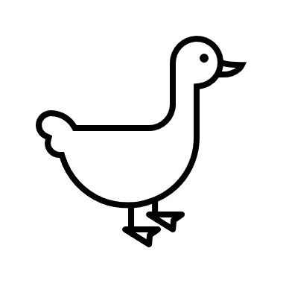
Wednesday 29th April
Today we are going to look at some of the past tense verbs that are used in the story of Brenda’s Boring Egg.
Remember verbs are usually words that can be described as ‘doing’ words (but they do include some words that are more about being such as is/was- don’t worry about these today though).

1. Read these past tense verbs and then put them into alphabetical order…there are 4 that all begin with g so you will have to look at the second or even third letter to sort these four out.
tucked gazed gloated gleamed emerged gasped nurtured
hatched

+
Mummy duck lays her eggs.

Wednesday 29th April continued
2. The words you have sorted are all in the past tense. What do they have in common that helps you to know they are in the past tense? (hint: its to do with the spelling)
_____________________________________________________________________

3. Definitions – Match the words on the left to the word or words on the right which mean the same thing.
Tucked shone or twinkled
Gazed boasted
Gloated put inside something
Gleamed looked
Emerged spoke with a shocked voice
Gasped came out of an egg
Nurtured appeared or came out of
hatched looked after (as it grew)

4. Choose 3 of the words from the first column that you would like to remember to use. Write a sentence using each word.
5. Making the present tense – If you take the -ed ending from these past tense verbs you will get back to the root word. If you add an s to the root word you will make the present tense verb (after using he/she/it)
Rewrite these sentences in the present, not past tense.
i. She gazed at their eggs with a sorrowful sigh.
_______________________________________________________________________
ii. She gleamed with delight.
________________________________________________________________________
iii. A duckling emerged with the softest of down.
_______________________________________________________________________
iv. The mummy ducks all gasped as the ducklings all hatched.
______________________________________________________________________
Thursday 30th May
Slow Writing Day – follow the sentence rules to write about this picture.
My example – try to think of your own ideas
1. One sunny morning in spring, a cute baby duckling went for his very first swim.
2. His soft yellow body bobbed along as his large webbed feet pushed him quickly through the clear, cool water.
3. All around him he could hear birds singing, the water lapping and he quacked with delight.
4. I wonder what it is like under the water?
5. Sticking his tail in the air, he dived down below and was surprised to see a shiny silver fish swimming beside him.

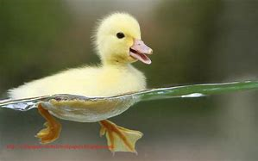

One sunny morning in spring, a cute baby duckling

Rules to follow to write your first five sentences
1. Sentence 1 should start with an adverbial phrase for time (e.g. Early one morning/one fine day or something similar)
2. Include at least 2 expanded noun phrases (phrases that describe something) to describe what the duckling looks like.
3. Talk about sounds and use a comma in a list.
4. Write a question that the duckling might ask himself – don’t forget the punctuation.
5. Start the sentence with a verb ending with -ing to describe what the duckling does next.

____________________________________________________________________________________________________________________________________________________________________________________________________________________________________________________________________________________________________________________________________________________________________________
Use your book if you need more space. _
Friday 1st May
Story writing day
Read the story of Brenda’s boring Egg one more time Today you are going to write a story about what happens to the ducklings as they get bigger. Remember one of the mummy ducks thought their duckling would grow up to be very clever, one thought their duckling would a Rockstar and one thought that their duckling would be very creative. Brenda’s mum just hoped that her duckling would be kind and loving.
In the end all the ducklings looked the same so perhaps they will all grow up to be alike? They could be clever, creative, Rock stars, champion flyers, fast swimmers, great divers or something else. Can you make up a story about what happens to them. You might want to give them names…remember two were ‘hims’ and two were ‘hers’
You might want to draw a story plan of 5 or 6 events first. Keep the pictures simple so you have time to do the writing. You can ask your family for help with ideas, but try to make the sentences your own when you come to write them.
You could start your story something like this.
Many months passed and the four duckling friends grew their adult feathers. One day they decided it was time to leave their mummy ducks and go out into the world.

Friday 1st May
L.O: To write a story
Success Criteria
Must:  - Write in sentences with full stops and capital letters  - Form letters correctly  - Check it all makes sense | Should:  - Check your spellings  - Use some co-ordinating (and/but/or) and subordinating (when/if/that/because ) conjunctions  - Use time phrases to move the story on. | Could:  - Use joined handwriting  - Use apostrophes correctly to show missing letters or belonging  - Include some dialogue with a question.

Write your story in your books.
You might not finish it in one day, so if you get really tired and you have tried really hard, then you can stop part way through. Try to finish it another time if you can.

