Progression of Skills and Knowledge in Geography
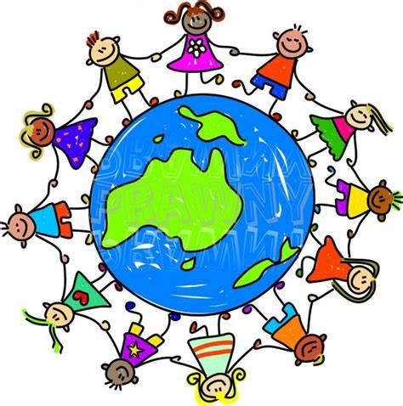
KNOWLEDGE, SKILLS AND UNDERSTANDING
 | Year 1 and 2 | Year 3 and 4 | Year 5 and 6
Locational knowledge | - I can mark on a map of the British Isles the place where I live and capital cities of the four countries  - I can mark on a map of the World, The British Isles, my country of birth and other locations  - I can name the 7 continents of the world  - I can name the 5 oceans of the world  - I can name the capital cities of the UK  - I can name the seas surrounding the UK | - I can use a map to locate 4 European countries on a world map  - I can locate counties and cities in the UK  - I can identify human and physical characteristics of places  - I can explain how places have changed over time  - I can understand what different maps are telling me  - I can use the internet to help find out about a location (Google Earth)  - I know that a map is a flat representation of a place on the globe | - I can use a map to locate 6 of the world’s countries beyond Europe  - I can use locational vocabulary to describe different places e.g. longitude, latitude, Equator  - I understand the significance of GMT and time zones  - I can understand what different maps are telling me
Place knowledge | - I can identify similarities and differences between the four countries of the UK  - I can compare Potters Bar to a small town in China | - I can give similarities and differences between regions across the world  - I can create a geographical fact file about a world country | - I can give similarities and differences between regions across the world  - I can summarise an environmental issue either in the local area or an area I am studying
Human and physical geography | - I can locate hot and cold areas of the world  - I can describe weather patterns for different seasons  - I can use geographical language to describe places | - I can explain how mountains, volcanoes and earthquakes are formed  - I can name different types of settlements and explain how they have changed over time  - I can explain how the water cycle works | - I can explain the key aspects of climate zones  - I can identify the parts of a river and how land use is different along its course  - I understand economic activity
Geographical skills and fieldwork | - I can ask questions about people and places  - I can take digital photographs of a locality and use them to describe a place  - I can use simple compass directions  - I can describe routes on a map  - I can use photographs and plans to recognise landmarks  - I can create a simple map with a simple key  - I can use simple fieldwork skills to study the school and local environment | - I can use maps, atlases and computer mapping to locate countries  - I can use the 8 points of a compass | - I can use 4 and 6 figure grid references, symbols and keys  - I can use fieldwork to present data in a range of ways  - I can use the internet to help find out about a location (Google Earth)

