Progression of Skills and Knowledge in Art & Design
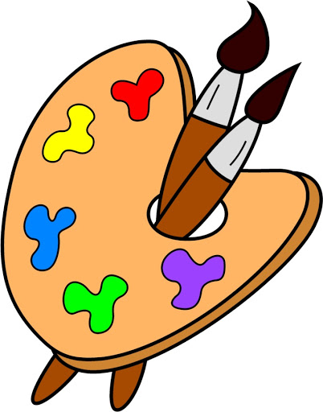
KNOWLEDGE, SKILLS AND UNDERSTANDING
 | Year 1 and 2 | Year 3 and 4 | Year 5 and 6
Drawing | I can draw lines of different shapes and thicknesses. | I use different grades of pencil at different angles to show different tones. | I use shading to show shadows and reflections on 3D shapes.
 | I can colour in neatly, following the lines very carefully. | I use pencils, pastels and charcoal in drawings. | I select the most suitable drawing materials for the type of drawing I want to produce.
 | I show different tones using coloured pencils | I can identify and draw simple objects, and use marks and lines to produce texture. | I use hatching and cross hatching to show tone and texture in my drawings.
 | I sketch lightly (so I do not need to use a rubber) | I use a viewfinder to help me in my sketching | I annotate my sketches in my art sketchbook to explain my ideas.
Painting | I can use thick and thin brushes. | I use watercolour paint to produce washes for backgrounds and then add detail. | I use a number of brush techniques using thin and thick brushes, to produce shapes, textures, patterns and lines.
 | I mix primary colours to make secondary colours. | I know the positions of primary and secondary colours in relation to each other on the colour wheel. | I can create all the colours I need by missing colours.
 | - I add white to colour to make tints and black to colour to make tones. | - I can create a background using a wash. | - I experiment with different colours and shapes to create or reflect a feeling or mood.
Collage | - I have explored and experimented with lots of collage materials.  - I can cut and tear paper and card for my collage. | - I can cut very accurately.  - I can overlap different collage materials. | - I can justify the materials I have chosen for my collage  - My collage combines both visual and tactile qualities.
 | - I can gather and sort the materials I will need.  - I can use repeated patterns | - I can say how other artists have used texture, colour, pattern and shape in their work.  - I can use ceramic mosaic to produce a piece of art | - I look at mosaic, montage and collage from other cultures and use their methods in my own work.
3D Work/Textiles | - I can add texture by using tools | - I can add texture and shape to my work.  - I can create pop-ups. | - I can combine materials and process to design and make 3D form.  - I can include both visual and tactile elements to my work.
 | - I can cut, roll and coil materials such as clay, dough or plasticine. | - I can begin to sculpt clay and other mouldable materials | - I can sculpt clay and other mouldable materials.  - I can create models on a range of scales.
 | - I make weavings with fabric or threads.  - I use glue to join fabrics. | - I can join fabrics together.  - I can use early textile and sewing skills as part of a project. | - I can use textile sewing skills as part of a project. This could include:  Hanging, textile book, running stitch, cross stitch.
 | - I use running stitch to join fabrics. | - I have the basics of cross-stitch and back-stitch. | - I have a sound understanding of how to use the technique of sewing (cross stitch and backstitch) applique, embroidery, plaiting, finger knitting.
Printing | - I can print with sponges, vegetables and fruit | - I can make a printing block. | - I can print using a number of colours.  - I can create an accurate print design that meets a given criteria.
 | - I can create a print using pressing, rolling, rubbing and stamping. | - I can make a 2 colour print.  - I can print onto different materials. | - I can look carefully at the methods I use and make decisions about the effectiveness of printing methods.
Communication  (Including ICT) | - I can use a simple painting program to create a picture | - I can use IT programs to create a piece of work that includes my own work and that of others (using internet) | - I can use a software packages to create pieces of digital art  - I can create a piece of art work which includes the integration of digital images I have taken.
 | - I can use tools like fill and brush in painting package. | - I can combine graphics and text based on my research. | - I can create a piece of art work which can be used as part of a wider presentation.
 | - I can go back and change my picture.  - I can take different photographs of myself displaying different moods.  - I can change my photographic images on a computer. | - I can take different photographs of myself displaying different moods.  - I can change my photographic images on a computer. | - I can scan images and take digital photo, use software to alter them, adapt them and create work with meaning.

